***Creation of Customize Amazon Machine Image (AMI)***

**Scenario:-**

Requirement is we want to create **multiple EC2 Instances with Web Server and DHCP Server** across **multiple AZ and Multiple Region**. Instead of Creating all the instances at a time we can create one EC2 instance with Web and DHCP Server. Then we will create an AMI of this EC2 Instance so that whenever requirement comes, we can use this AMI to create EC2 Instances according to our requirement.

This Created AMI is called Customized AMI.

**Architecture**

The above architecture is self-explanatory we created one Windows EC2 Instance and to the created Ec2 Instance we installed DHCP and Webserver. Then created Customized AMI of that EC2 Instance, Using This AMI we created multiple EC2 Instances, these created EC2 Instances will have DHCP and Web Server installed at the time of creation no need to install those again.

**LAB**

**Tasks:-**

1. Create New EC2 Instance
2. Change password and Install Necessary Services into newly created EC2 instance.
3. Create AMI Image of EC2 instance.
4. Create a New EC2 instance from AMI.
5. Access and verify EC2 instance made from AMI.

**Steps:-**

1. **Create a new EC2 instance.**

Login to your aws console [https://aws.amazon.com/](https://aws.amazon.com/%20)

Go to EC2

From EC2 Dashboard Launch instance.

Give **Name** to EC2 Instance and Select **Microsoft 2022 server Base** AMI.

Select **Instance Type** ( Select T2.micro ) and **Key pair** (Used existing Key Pair).

In **Network Settings**

* Verify default VPC has been selected
* Auto-assign Public IP must be enable

Here we need to add a rule in **Security Group.**

Click on **Add security group rule.**

Next Step is to **Configure Storage**

Keep it default (30 GB EBS Volume).

Click on Launch Instance.

Instance got created and 2/2 checks also passed.

1. **Change password and Install Necessary Services into newly created EC2 instance.**

**Note:**

* Here I am not going to explain how we will connect to our EC2 instance using RDP client since it’s already explained in my previous projects.

Imp:- Since the EC2 launched Using Customized AMI can not use .pem key file for login, we must change the administrator password of our main created EC2 Instance before creating AMI.

Navigate to 🡪 Server Manager

Navigate to 🡪 tools 🡪 Computer Management

Now Navigate to “Local Users and Groups”

Double click on Users

Now Right click on administrator🡪 set password

Click on ok

Reset password to manu@123. Now close the RDP client and open again now use the updated password to login.

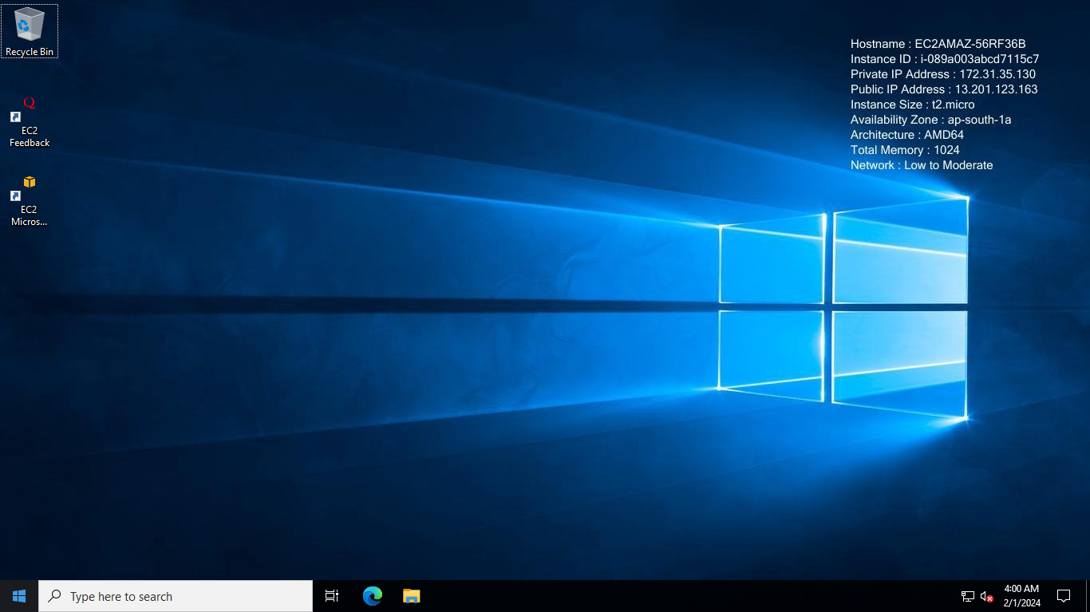

**Installing necessary services (Web Server and DHCP Server)**

Go to Server Manager Dashboard

* Click Add roles and Features

Click Next

No need to change anything click next.

Click on next

Now select DHCP Server

Click on Add Feature.

Now choose Webserver then click on add Features

Now Click on next

Click on next.

Click on Next

Click on Install

Wait till installation is completed.

Installation completed Close the window.

In tools windows D**HCP and IIS Manager** will be added newly indicating that webserver and DHCP Server got installed successfully.

**Checking the Web Server installation via Web browser.**

Copy the Public IP of our EC2 instance open new window in browser give the ip along with port 80 and http.

We get default IIS default page as below

1. **Creation of Custom AMI Using this EC2 Instance.**

Select the **AMI 🡪 Actions 🡪 Image and Templates 🡪 Create Image**

Give **Name**

If we want to add volumes we can add here, we will get default 30 GB volume. I a not going to add any extra volumes here.

Click on **create Image.**



Navigate to **Dashboard🡪AMIs.**

Status is “Pending “ it will take some time to create an AMI.

Now the status has changed to available. Now my AMI is ready.

1. **Create New EC2 Instance from the created AMI.**

**Note that this AMI available in Mumbai Region only,**

if we want to launch the instance is different region, we need to copy the AMI first then launch EC2 Instances using those AMI

🡪To copy the AMI🡪 Select the AMI🡪Actions🡪 Copy AMI

Click on Copy AMI, Now AMI will be **copied from Asia-pacific Mumbai to Asia-Pacific Tokyo Region,** Now we can create the ec2 instances in Tokyo region this AMI as well.

Now there **is two ways to create EC2 Instances** from AMI,

1. Traditional way

The steps are the same. Only one small change is that we here select our AMI, instead of selecting Linux or Windows AMI, AMI will be available in my AMI section.

We will add port 80 to the security group to allow inbound traffic from anywhere.

1. Creating EC2 Instances from AMI Dashboard.

Click on **Launch Instance from AMI**

The remaining steps are same creating an EC2 instance.

Give name,

No need to **select AMI** since it is already selected.

No need to create **Key-pair.** Select proceed without key pair.

In **network setting** Add one rule to allow port 80 (security group)

In the subnet section select second AZ(ap-south 1b).

In **configure storage** we can add storage if required.

I am not adding any storage.

Click on **Launch instance.**

Created Instance. Wait till 2/2 checks passed.

Got browser and give http:// 13.201.123.163:80 to get IIs Web browser home web page as below.

Connecting to new EC2 Instance via RDP client



Now here we directly give the updated Password of (First EC2 Instance).

Which is manu@123.

This should work because we launched this instance by using AMI of first EC2 instance in which the password is updated.

Home screen of second EC2 instance. Windows Server -2 created in ap-south-1b

The first instance is in windows server 1 present in ap-south-1a.

We already validated whether we are getting webserver or not from Web browser using public IP of the second EC2 instance.

To validated after logging into the server Navigate to Server manager🡪 Tools

We can see both DHCP and IIS Manager.

It is smart way to use AMI to create multiple EC2 instances in different AZ and Different Region. It will save lot of time and the complexity we face when we create multiple(100s) of EC2 Instance.